Assignment
CASE STUDY
1. Compare the top 5 countries with the highest no. of patient vs recovery rate.
Query:
SELECT
Country,
SUM(Total_Cases) AS Total_Patients,
ROUND((SUM(Total_Recovered) * 100.0) / SUM(Total_Cases), 2) AS Recovery_Rate
FROM covid19vmimp
GROUP BY Country
ORDER BY Total_Patients DESC
LIMIT 5;
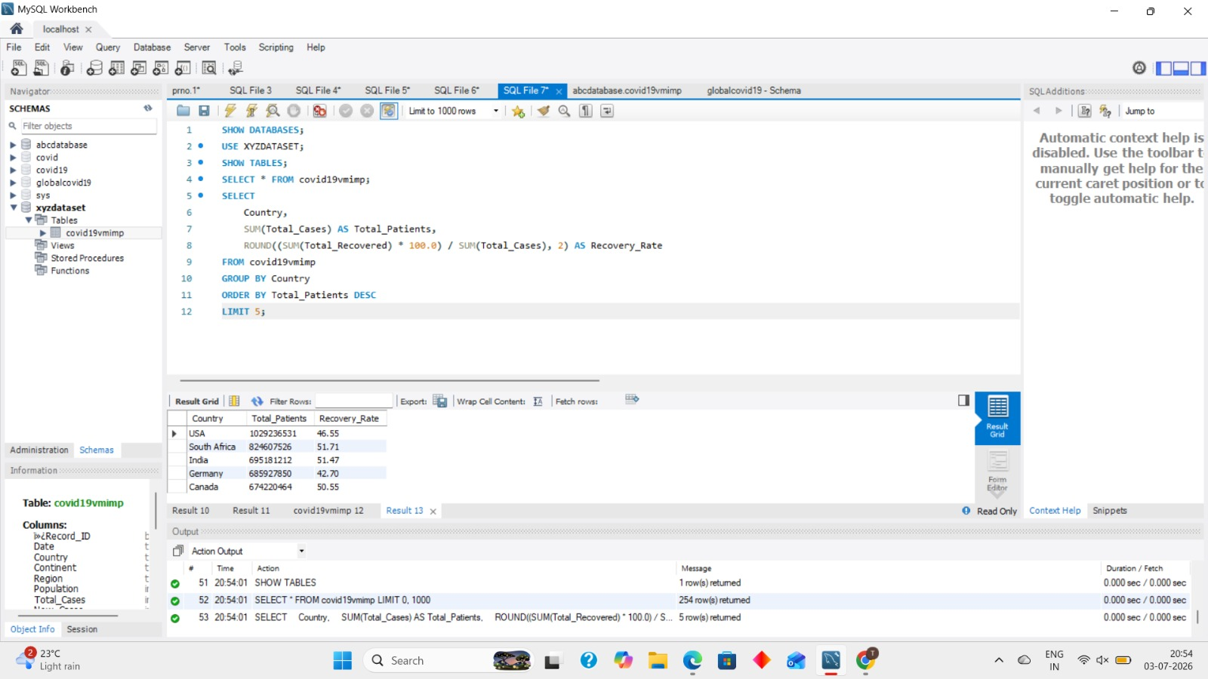
Insights:
The top 5 countries have the highest number of COVID-19 cases.
These countries also show their recovery rate, which helps compare how many patients recovered.
A higher recovery rate means a larger percentage of infected patients recovered successfully.
2. Find the Top 5 and Last 5 Countries with the Highest Vaccination Count.
Query:
SELECT Country,
MAX(Vaccination_Rate) AS Vaccination_Count
FROM covid19vmimp
GROUP BY Country
ORDER BY Vaccination_Count DESC
LIMIT 5;
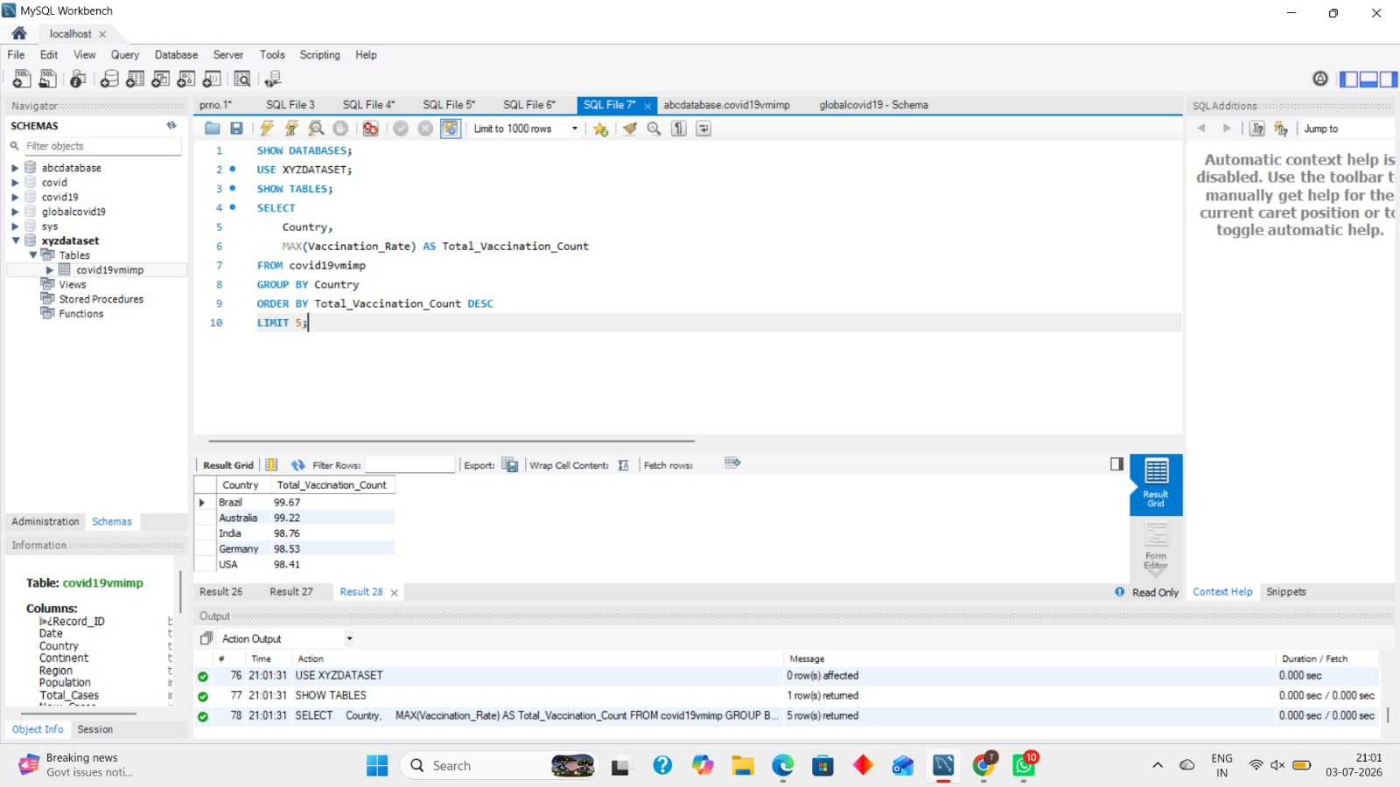
Insights:
These are the top 5 countries with the highest vaccination rate/count.
These countries have vaccinated more people compared to other countries in the dataset.
A higher vaccination count shows better vaccination coverage and stronger efforts to control COVID-19.

Query:
SELECT Country,
MAX(Vaccination_Rate) AS Vaccination_Count
FROM covid19vmimp
GROUP BY Country
ORDER BY Vaccination_Count ASC
LIMIT 5;
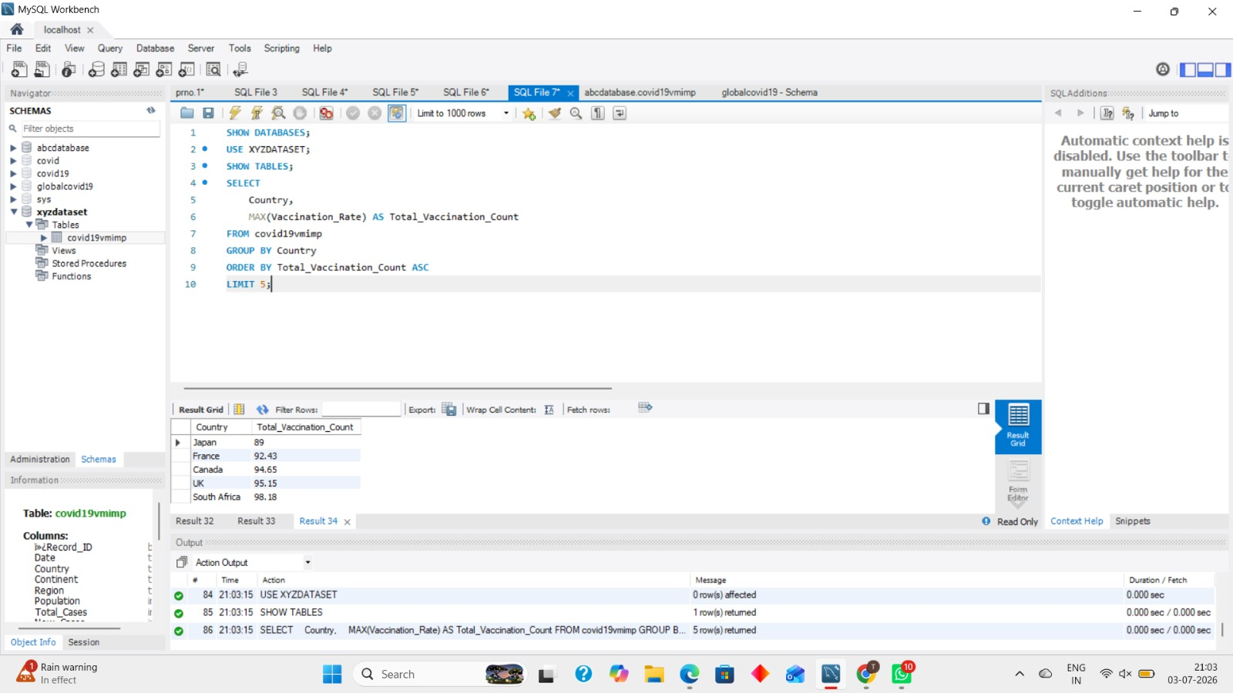
Insights:
These are the bottom 5 countries with the lowest vaccination rate/count.
These countries have vaccinated fewer people compared to other countries in the dataset.
A low vaccination count may indicate slower vaccination progress or limited vaccine coverage.
3. Show records where new deaths are greater than 100.
Query:
SELECT *
FROM covid19vmimp
WHERE New_Deaths > 100;
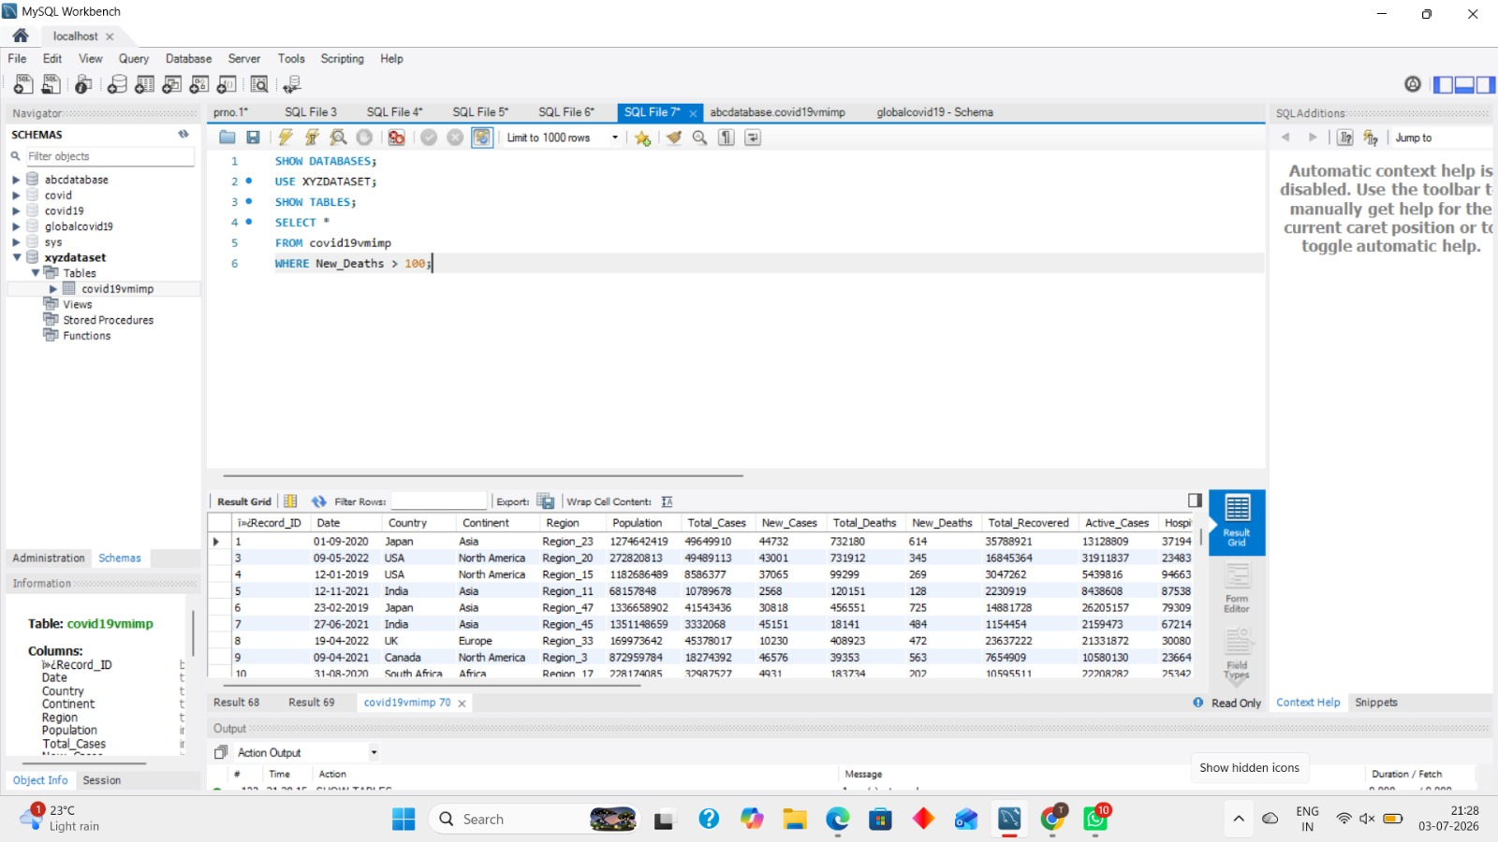
Insights:
This query displays all records where the number of new deaths is greater than 100.
It helps identify countries and dates with a high number of daily deaths.
These records indicate periods when the impact of COVID-19 was more severe.

4. Find the first date in the dataset.
Query:
SELECT MIN(Date) AS First_Date
FROM covid19vmimp;
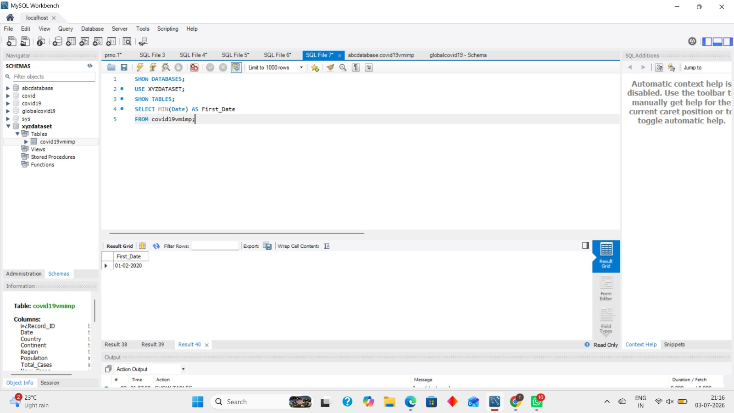
Insights:
This query finds the earliest date available in the COVID-19 dataset.
It shows when the dataset starts collecting COVID-19 records.
This date can be used as the starting point for time-based analysis and reports.

5. Calculate total cases by continent/country by using GROUP BY.
Query:
SELECT
Continent,
Country,
SUM(Total_Cases) AS Total_Cases
FROM covid19vmimp
GROUP BY Continent, Country
ORDER BY Total_Cases DESC;
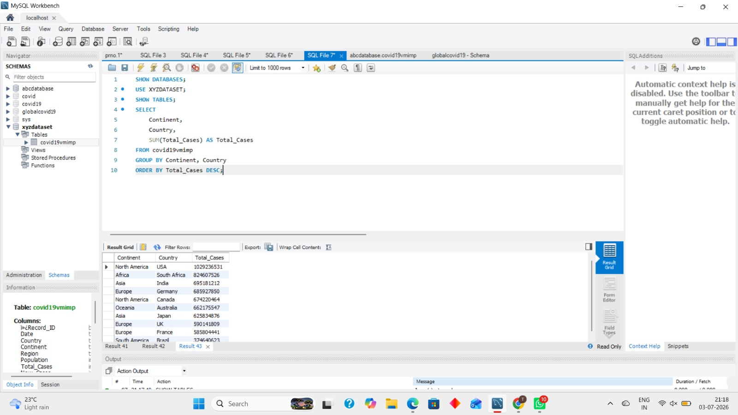
Insights:
This query calculates the total COVID-19 cases for each country and continent.
It helps compare which countries have the highest total number of cases.
The results are sorted from the highest to the lowest total cases.

6. . Dense Rank for Each Country :
Query :
SELECT
Country,
SUM(Total_Cases) AS Total_Cases,
DENSE_RANK() OVER(ORDER BY SUM(Total_Cases) DESC) AS Country_Rank
FROM covid19vmimp
GROUP BY Country;
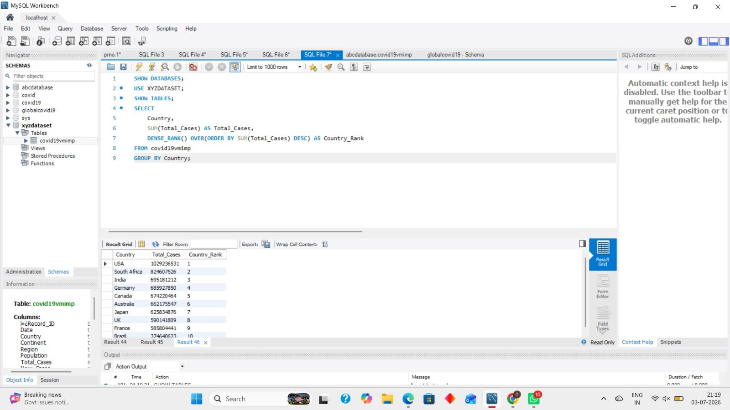
Insights:
Countries are ranked according to their total COVID-19 cases.
Countries with the same number of cases receive the same rank.
It helps compare country performance without skipping rank numbers.

7. Running Average of New Cases.
Query :
SELECT
Country,
Date,
New_Cases,
ROUND(
AVG(New_Cases) OVER(
PARTITION BY Country
ORDER BY Date
), 2
) AS Running_Average_New_Cases
FROM covid19vmimp;
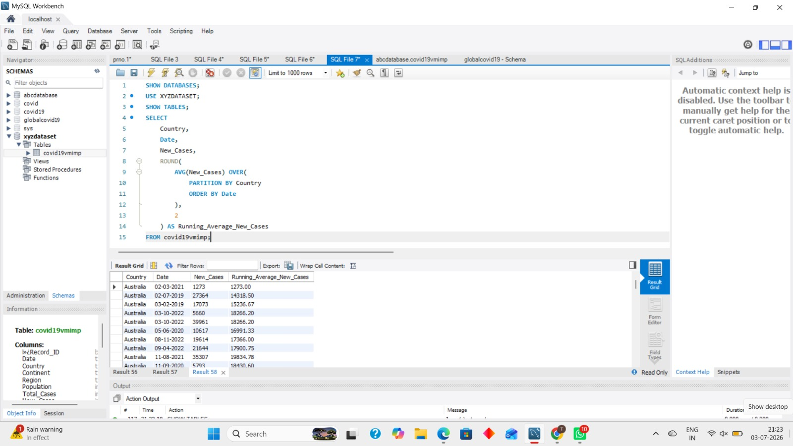
Insight :
The running average shows the overall trend of new COVID-19 cases.
It reduces the effect of daily fluctuations.
It helps detect whether infections are rising or declining.
8. Display the ICU Patients Risk Level by Country.
Query :
SELECT
Country,
ICU_Patients,
CASE
WHEN ICU_Patients >= 1000 THEN 'High Risk'
WHEN ICU_Patients >= 500 THEN 'Medium Risk'
ELSE 'Low Risk'
END AS Risk_Level
FROM covid19vmimp;
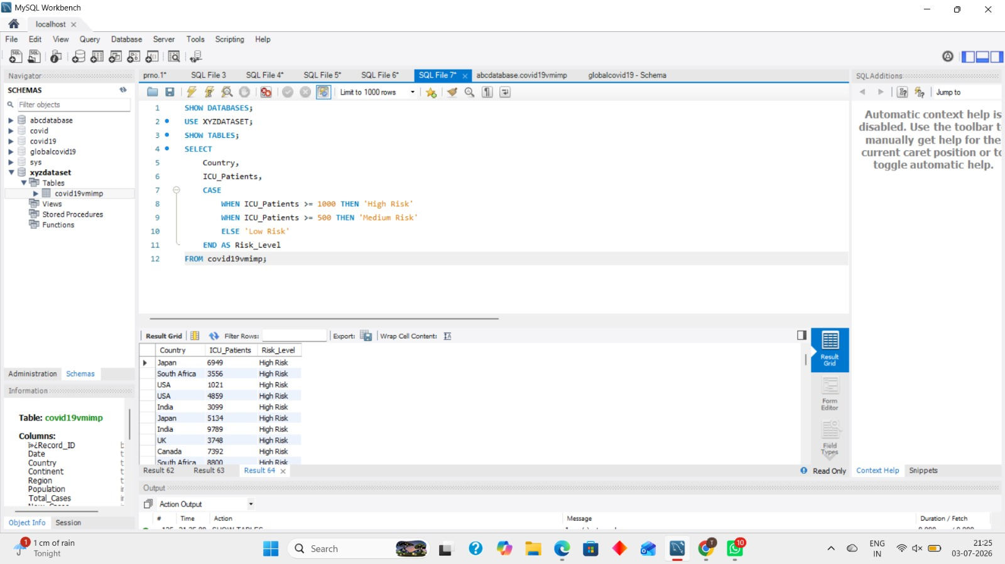
Insight :
Countries are classified into different risk levels based on ICU patients.
A higher number of ICU patients indicates greater pressure on the healthcare system.
This helps identify countries requiring urgent medical support.

9. Find Continents Where Average Vaccination Rate is Above 50% and below 50%.
Query :
SELECT
Continent,
ROUND(AVG(Vaccination_Rate),2) AS Avg_Vaccination_Rate
FROM covid19vmimp
GROUP BY Continent
HAVING AVG(Vaccination_Rate) > 50;
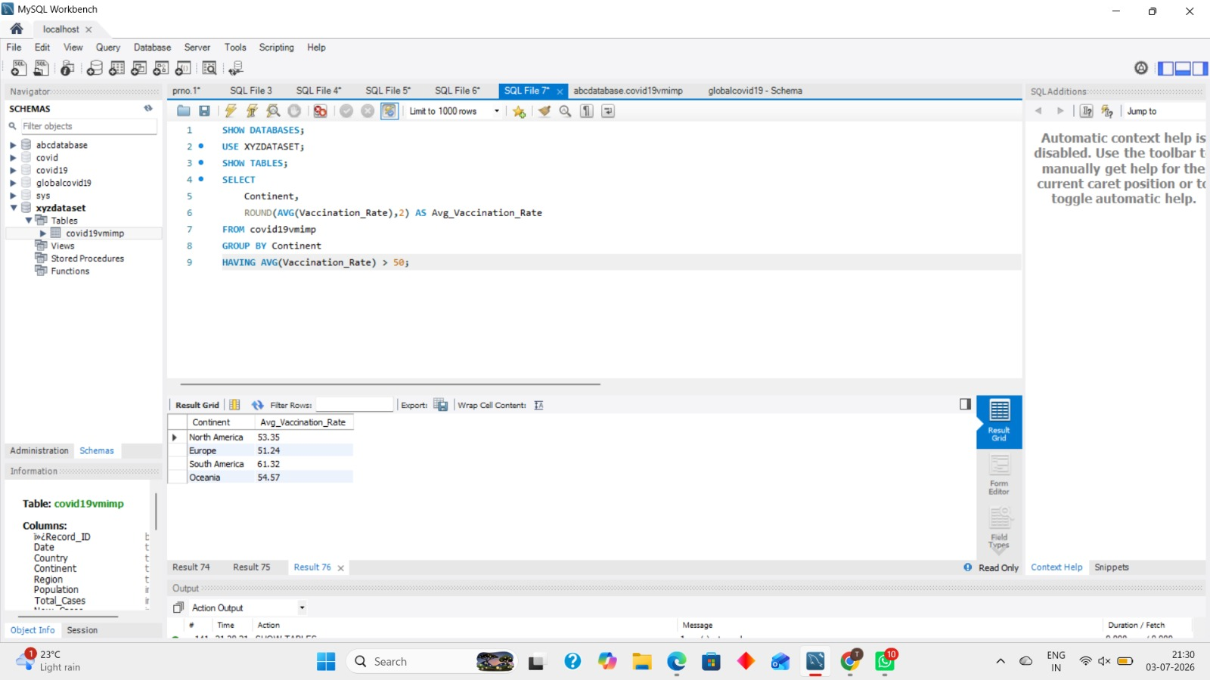
Insight :
This query identifies continents with an average vaccination rate greater than 50%.
These continents have achieved higher vaccine coverage, which helps reduce the spread of COVID-19.
A higher vaccination rate reflects effective vaccination programs and better public health efforts.
Query :
SELECT
Continent,
ROUND(AVG(Vaccination_Rate),2) AS Avg_Vaccination_Rate
FROM covid19vmimp
GROUP BY Continent
HAVING AVG(Vaccination_Rate) < 50;
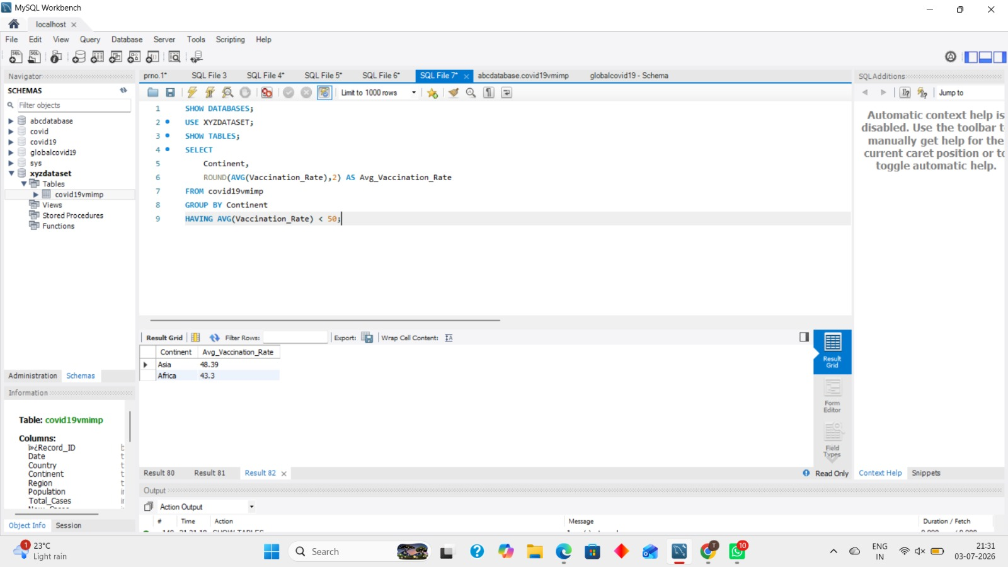
Insight :
This query identifies continents with an average vaccination rate below 50%.
A lower vaccination rate may increase the risk of COVID-19 transmission.
These continents may need stronger vaccination campaigns and healthcare support.
10. Display 5 Random Dates with the Running Total of Active Cases, New Cases, and New Deaths.
Query :
SELECT
Date,
SUM(Active_Cases) OVER (ORDER BY Date) AS Running_Active_Cases,
SUM(New_Cases) OVER (ORDER BY Date) AS Running_New_Cases,
SUM(New_Deaths) OVER (ORDER BY Date) AS Running_Deaths
FROM covid19vmimp
ORDER BY RAND()
LIMIT 5;
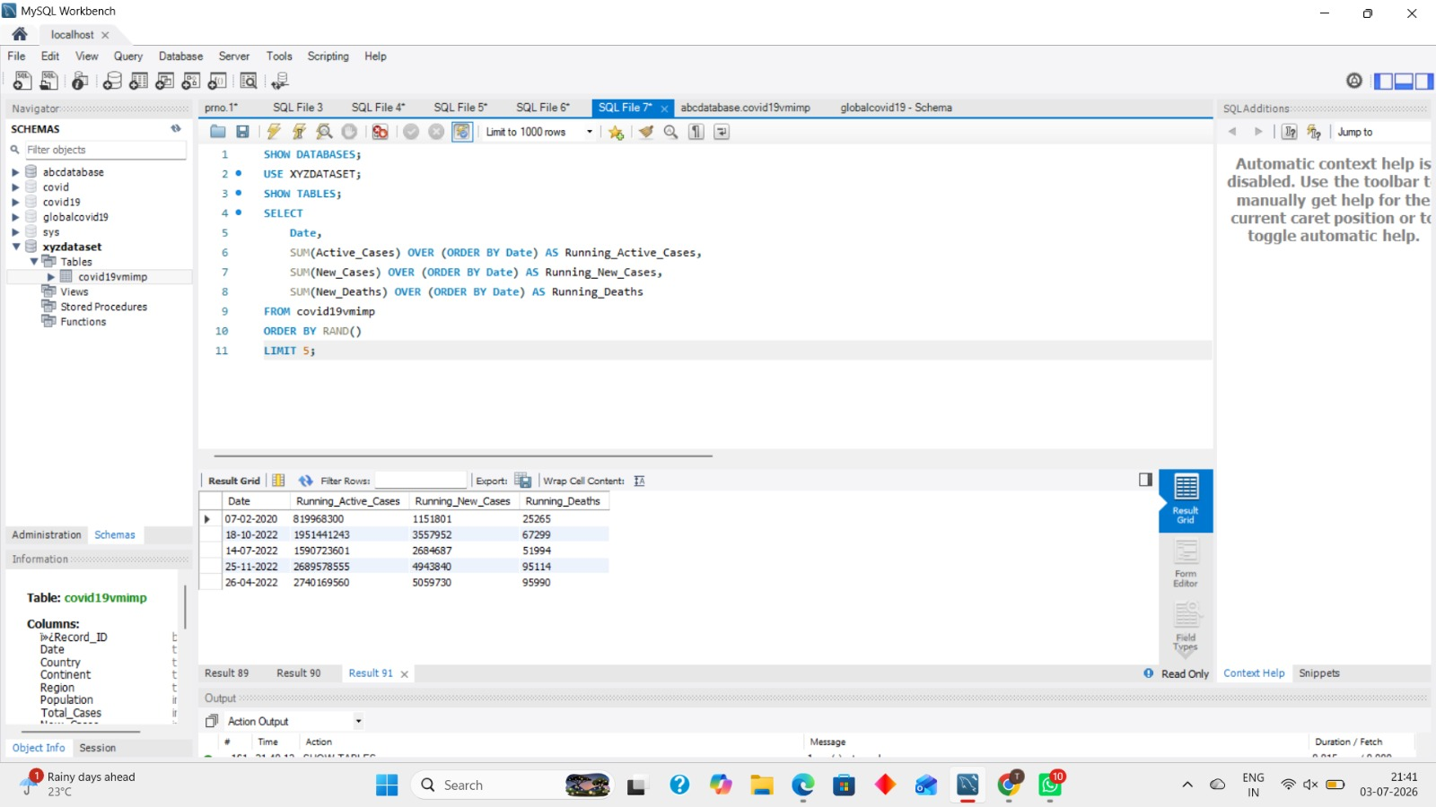
Insight :
This query displays 5 random dates with the cumulative (running) totals of Active Cases, New Cases, and New Deaths.
The running totals help track the overall growth of COVID-19 over time.
It provides a quick snapshot of the pandemic's progression on different dates.

